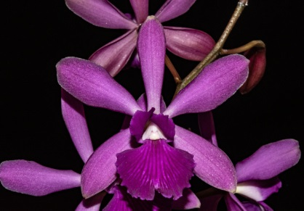
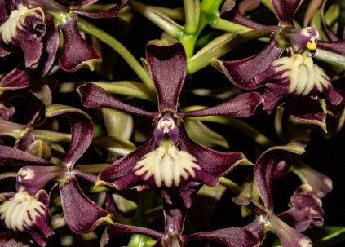
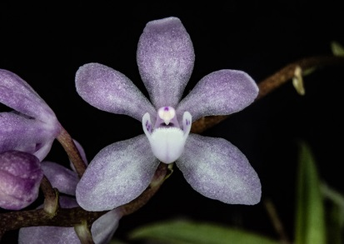
Catyclia PROVISIONAL Max & Bryon AM 86

Sarcochilus cociliae Bryon Rinke Am 81 Epidendrum arbuscular Bryon AM 81

