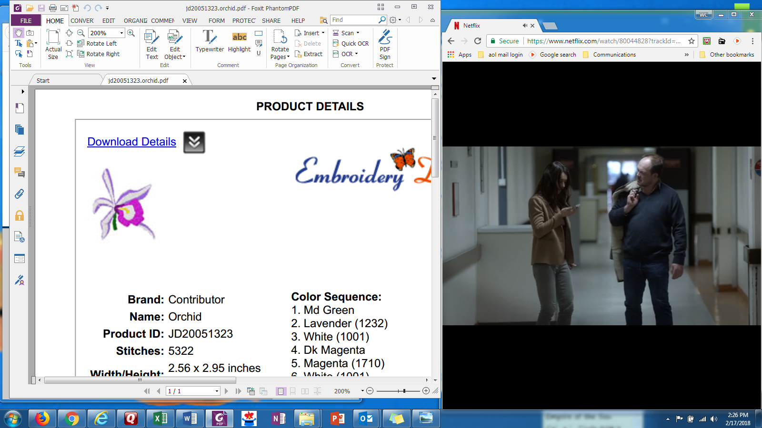 **FEATURED MEMBERS’ HIGHLIGHTS**

Sarah Pratt

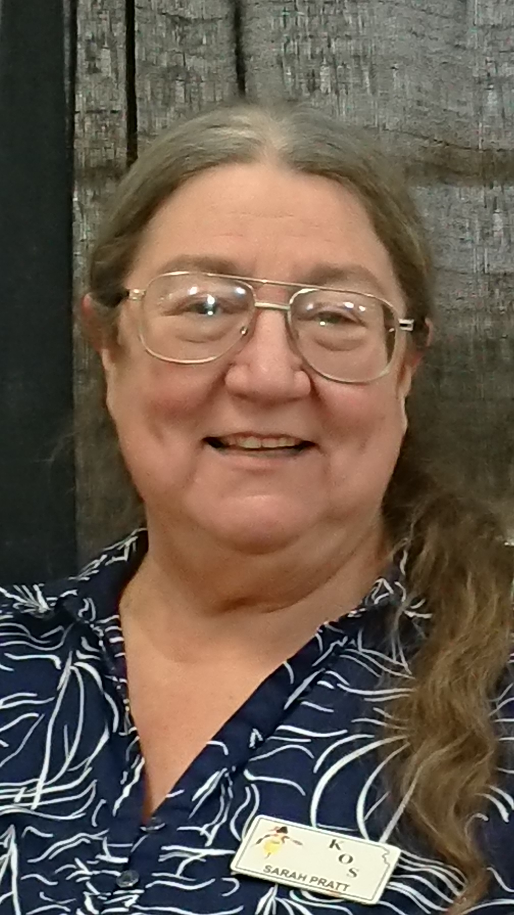Our featured member this month is Sarah Pratt. Sarah lives in Sedgwick, Kansas with her husband, Peter Aversa. She owns Timbucktoo Orchids and takes her beautiful plants to the various orchid shows in the central U.S. Her greenhouse is something to envy and she has a built-in humidifier (a pool) inside her greenhouse. Imagine in mid-winter enjoying yourself in a warm, enclosed pool with beautiful orchids blooming all around you! Sarah also often hosts the summer picnic for our club, buys plants for our shows and manages our club inventory for the raffles and Christmas parties.

1. **How long have you been in the Kansas Orchid Society?**

Probably at least 20 years, maybe 25 plus years.

1. **How did you start growing orchids?**

I bought my first orchid the year after I graduated from college. It was a very lovely little white phal with a red lip and it took me three years to kill it.

1. **What do you like about growing them?  And what do you dislike?**

**Like**—The endless variety.

**Dislike: --**The endless variety. I will never own one of each or be able to

successfully grown them all.

1. **How many orchids do you have and where do you grow them?**

I have too many and not enough. I grow them in a commercial grade greenhouse – 30 ft x 48 ft - Lexan polycarbonate triple wall, automatic Wadsworth climate control. It was built as part of our new house construction project - about 10 years now.

1. **What do you particularly favor? and why?**

My very favorite is the semi-alba cattleya (white with a purple lip). Why? because they are classic and I’m not.

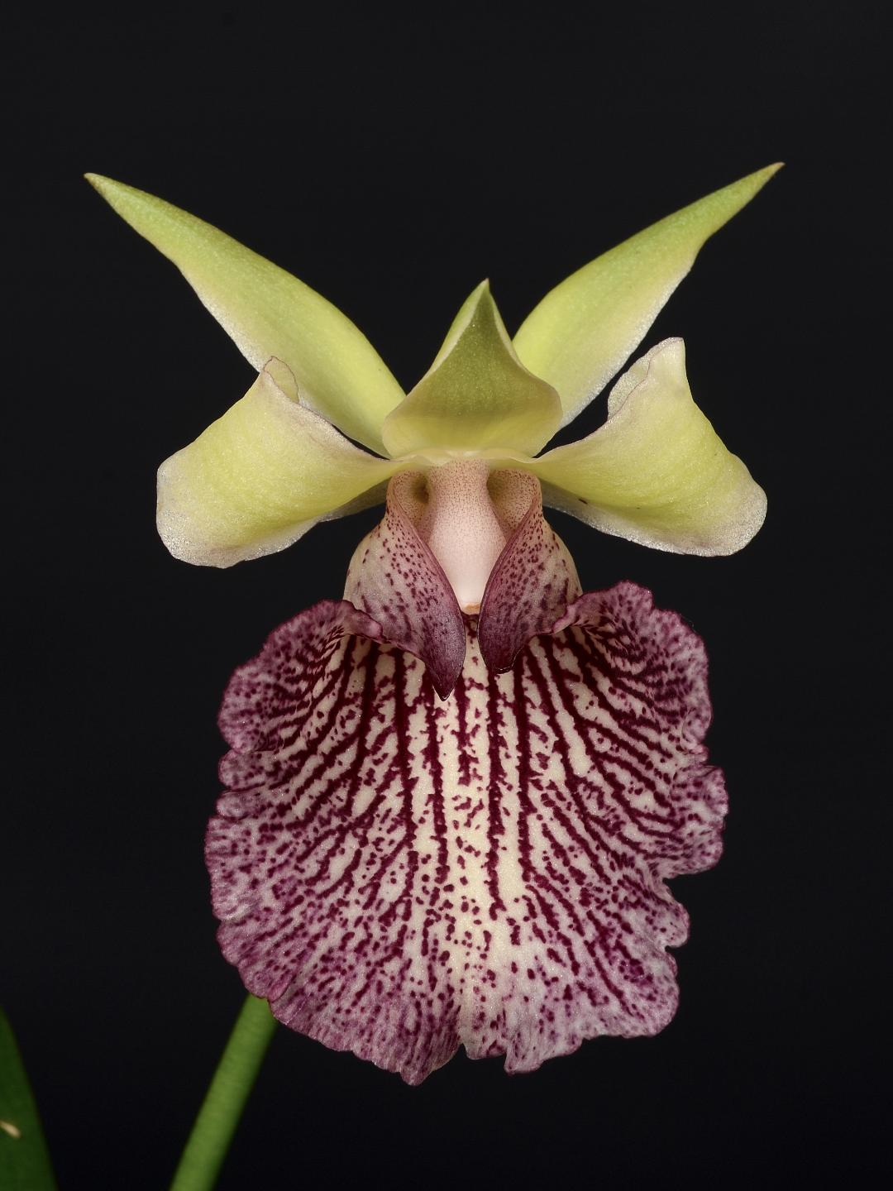

1. **Which orchid is the most difficult for you to grow?**

Psychopsis papilio Along time ago, I bought a compot with 40 plants in it. I grew them all up, they bloomed and were gorgeous. Since then I have been spectacularly unsuccessful.

.

1. **A bloom of which I am particularly proud** is the Warczewiczella [W.] timbiensis ‘Timbucktoo’ HCC AOS. It is shown to the right.
2. **Any experiences you would like to share with others? Words of wisdom?**

Resign yourself to the fact that you will never know everything there is to

know about orchids. One the other hand, you will never get bored.

1. **What are your other passions?**

This one has consumed all the others!

1. **Please tell us something we do not know about you.**

When I was young & foolish, I really like jumping horses over fences, somewhat successfully (sometimes not so much). My real job is as a veterinarian. I still own a practice in Sedgwick. My favorite breed is Spuds McKenzie, or the Target dog, i.e.: the bull terrier. I prefer the colored ones. I have done some emergency medicine but currently my practice is restricted to companion animals. Formerly I also have treated cows, horses and the like.