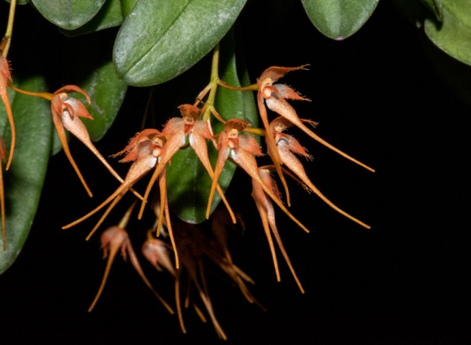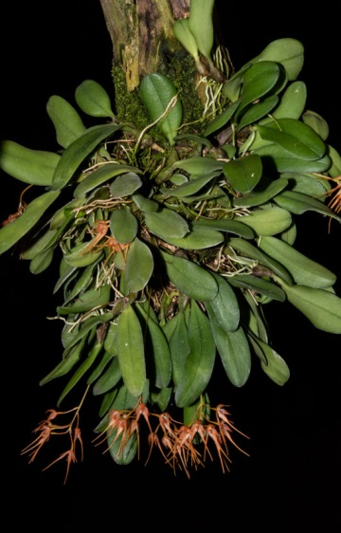

Bulbophyllum Taiwanense Bryon AM

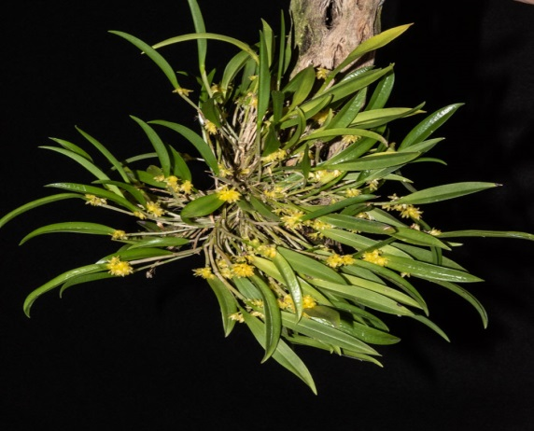

Bulbophyllum Taiwanense Bryon AM

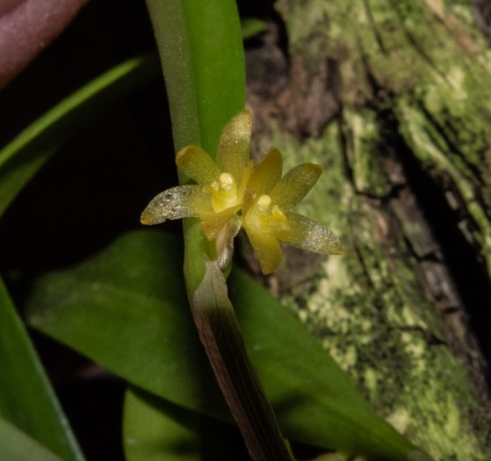

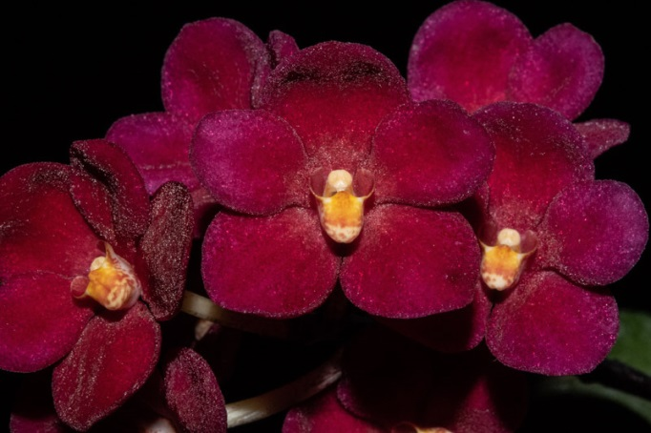

Sarcochilus Kulnura Whomping Bryon HCC

Octomeria Micrantha Bryon AM-CCM

Octomeria Micrantha Bryon AM-CCM