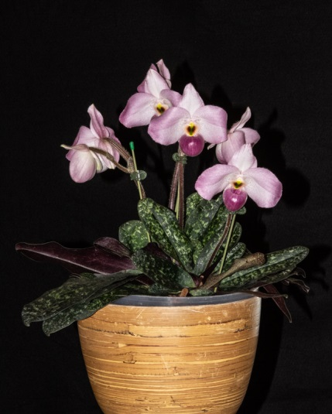

Paph Ho Chi Minh Jana Butcher Am- CCM

Paph Red In Flight Reyna’s Spring Wings HCC

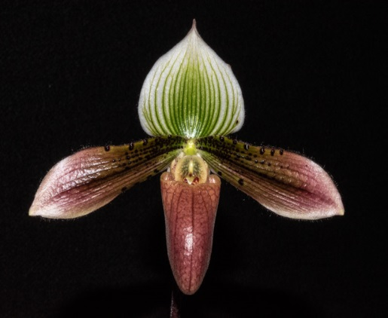

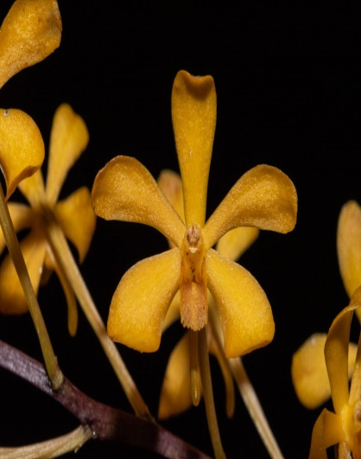

Vanda Alan Ashe Patterson Potsy’s Dink Dink HCC

Paph Ho Chi Minh Jana Butcher Am-CCM

